**WEEK 1 HANDS ON EXERCISE - DESIGN PRINCIPLES AND PATTERNS**

**Exercise 1: Singleton Pattern**

PROBLEM STATEMENT:

You need to ensure that a logging utility class in your application has only one instance throughout the application lifecycle to ensure consistent logging.

CODE:

Logger.java

public enum *Logger* {

***Instance***;

// Enum constant, automatically creates only one instance

public void logger (String message) {

System.***out***.println(message);

}

}

TestSingleton.java

public class TestSingleton {

public static void main (String args[]) {

*Logger* l1 = *Logger*.***Instance***;

*Logger* l2 = *Logger*.***Instance***;

l1.logger("User Logging l1...");

l2.logger("User Logging l2...");

if (l1 == l2) {

System.***out***.println("Both Logger instances are the same.");

}

else {

System.***out***.println("Different instances exist!");

}

}

}

OUTPUT:

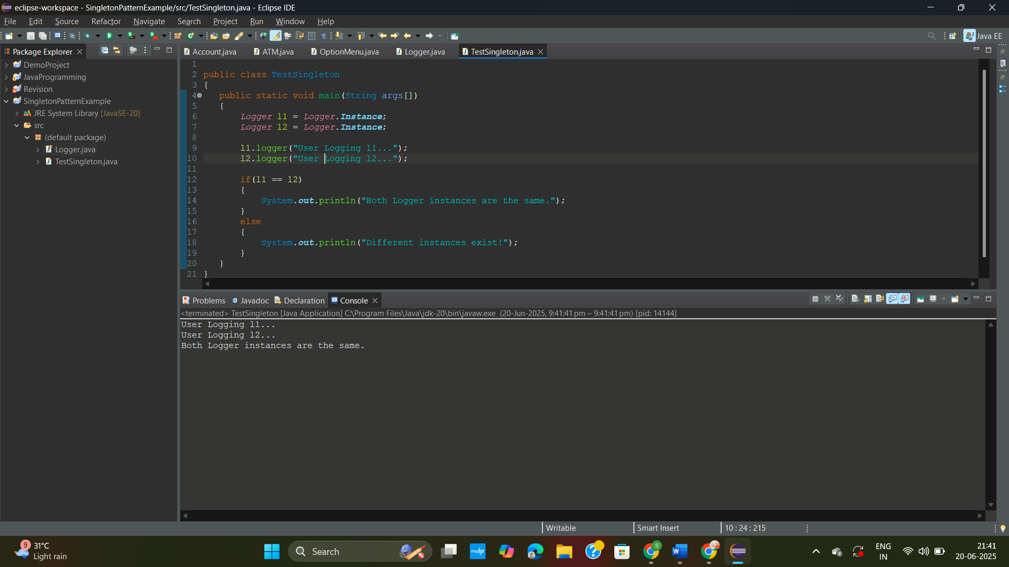

**Exercise 2: Factory Method Pattern**

PROBLEM STATEMENT:

You are developing a document management system that needs to create different types of documents (e.g., Word, PDF, Excel). Use the Factory Method Pattern to achieve this.

CODE:

Document.java

package FactoryMethodPatternExample ;

public interface Document {

void open();

}

ExcelDocument.java

public class ExcelDocument implements Document{

*@Override*

public void open() {

System.***out***.println("\nOpening Excel using MS Excel!..\n");

}

}

PdfDocument.java

public class PdfDocument implements Document{

*@Override*

public void open() {

System.***out***.println("Opening PDF using Adobe Reader!..\n"); } }

WordDocument.java

public class WordDocument implements Document{

*@Override*

public void open(){

System.***out***.println("Opening Word using MS Word!..\n");

}

}

DocumentCreator.java

package FactoryMethodPatternExample;

public abstract class DocumentCreator {

public abstract Document createDocument();

// we ensure that it must be openable;

}

ExcelDocumentCreator.java

package FactoryMethodPatternExample;

public class ExcelDocumentCreator extends DocumentCreator {

public Document createDocument() {

return new ExcelDocument();

}

}

PdfDocumentCreator.java

package FactoryMethodPatternExample;

public class PdfDocumentCreator extends DocumentCreator {

public Document createDocument(){ return new PdfDocument();

}

}

WordDocument.java

package FactoryMethodPatternExample;

public class WordDocumentCreator extends DocumentCreator {

public Document createDocument(){

return new WordDocument();

}

}

Main.java

package FactoryMethodPatternExample;

public class Main {

public static void main(String args[]){

DocumentCreator creator1 = new ExcelDocumentCreator();

Document excel = creator1.createDocument();

excel.open();

DocumentCreator creator2 = new WordDocumentCreator();

Document word = creator2.createDocument();

word.open();

DocumentCreator creator3 = new PdfDocumentCreator();

Document pdf = creator3.createDocument();

pdf.open();

}

}

OUTPUT:

